Dashboard :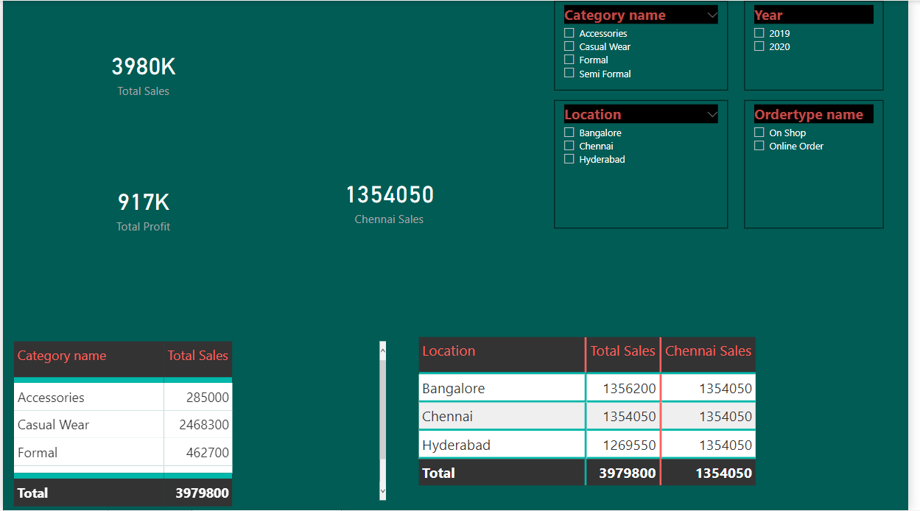

Based on the Dashboard above ,  
Perform the following assignments.

* Create a slicer of category name
* Create a slicer of year
* Create a slicer of order type
* Create a slicer of Location
* Show the total sales in card visual
* Show the total profit in card visual
* Show the total profit for “Bangalore” Location.
* Show profit % for Hyderabad Location
* Show the total sales for “Chennai” Location.
* Create a matrix visual to show the total sales by Category name
* Create a Barchart visual to show total profit across different locations.
* Create a matrix visual to show the total sales by location and years.

Check the multiple slicers and check the values.